Our power needs proved to be our second biggest challenge as our design requirements are quite aggressive. The device must meet or exceed the following expectations:

1. Last 24 hours while collecting data
   1. Only change or charge device at most once per waking day
   2. We calculated the capacity of our system had to provide at minimum 240mAh
2. Be medically safe
   1. Do not return DC current into needle probe into brain
   2. Do not heat up above 2 degrees centigrade
3. Be within the total size constraints of maximum 8mm diameter by 10mm height

Powering such a device that is so small yet so power hungry proves to be a big challenge that required extensive energy research. The research ranged from unconventional medical device techniques such as wireless charging[1] to tried and true conventional methods such as batteries. Given that the brain is a very sensitive and important part of our lives and our device will be directly interfacing with it, we decided to go with the more conventional and safer option of powering the intracranial EEG data recorder with batteries. However, even with battery technology as the chosen one, there was still a ton of work to be done in order to decide on a battery technology that could best fit our needs.

The first area of research would be the battery chemistry to use for our battery. Items that were under consideration were energy density, discharge rate, safety, weight and size, and lastly cost. There were dozens of battery chemistries, each with their pros and cons for specific applications in regards to performance and cost. In figure 1[2], the 6 most common battery make-ups are compared but only Lithium[3] based batteries could provide us the energy density for the size, weight, and capacity that we required. However even then, Lithium based batteries, while popular, could not be the only technology we look into as it still had several cons despite class leading energy density and low discharge rate. A flaw in Lithium based technologies is that it requires protection circuits to limits voltage and current and the lithium battery is safe if not provoked by extreme temperatures or physical damage. While these were somewhat minor cons that could be designed against to meet our second requirement of being safe, we researched into less conventional batteries such as silver-zinc and zinc-air[4].

Zinc-air, a less conventional battery chemistry but now highly common in hearing-aid devices, caught our attention and seemed to be a viable competitor to Lithium based batteries. Zinc-air batteries generate electrical power by an oxidation process of zinc and oxygen from the air and as such it has high specific energy, low discharge, and comes in a variety of sizes while also staying low-cost[5] and low weight due to the lack of need to package atmospheric air for its operation.

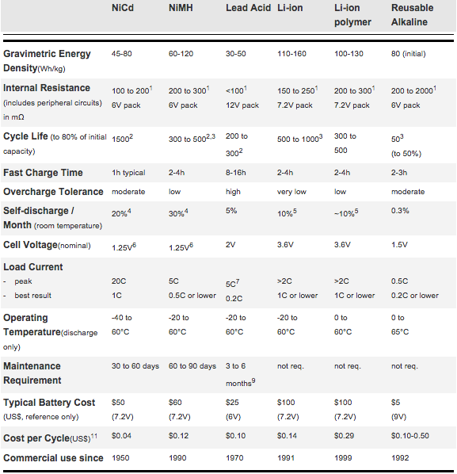

Figure 1: Comparison of 6 Common Battery Types

Given the choice between Zinc-Air and Lithium, we decided that while Lithium has a slightly higher energy density, its power stability cons and bigger standard size factors[6] were a limiting factor for us. We decided that Zinc-air’s small form factors would be our best viable option. The zinc-air batteries that we found for medical hearing aids came in 4 standard sizes, shown in figure 2, with varying diameter, height, and capacity. The only issue that we found was that the zinc-air batteries only provides 1.45V per cell but enough capacity at 300mAh at the p13 size. We believe that if we stack 2 p13 cells in series, we can get away with powering our devices at 2.9V, which is close enough to 3V, and that will continue to give us the 300mAh of the battery. This should be sufficient for our needs if our calculations are correct that our device should consume about 240mAh, which will give us 60mAh of buffer. This means that our capacity constraints are met but our size constraint would be slightly taller than what is optimal, as two batteries stacks would be 10.8mm, not including the rest of the components. However, we can ask for a height exception, as we would be creating prototypes and not creating custom batteries, which if we do for the production run, the battery size can fit with in size constraints.

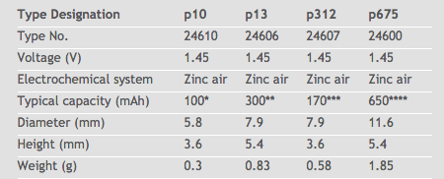

Figure 2: Zinc Air Battery Sizes

**Sources (Listed in order 1-5):**

Tseng, R., B. Von Novak, S. Shevde, and K. A. Grajski. "Introduction to the Alliance for Wireless Power (A4WP) Loosely- Coupled WPT Specification 1.0." Introduction to the Alliance for Wireless Power (A4WP) Loosely- Coupled WPT Specification 1.0 (2013): n. pag. IEEE, 15 May 2013. Web. 21 Oct. 2015. <https://www.rezence.com/sites/default/files/IEEE%20WPTC%202013%20A4WP%20Intro%20Keynote%20(FINAL%2013May2013).pdf>.

"What's the Best Battery?" Advantages and Limitations of the Different Types of Batteries. Battery University, 01 Nov. 2010. Web. 21 Oct. 2015. <http://batteryuniversity.com/learn/article/whats_the_best_battery>.

"Battery Chemistry Comparison Chart." Battery Chemistry Comparison Chart. ICCNexergy, n.d. Web. 21 Oct. 2015. <http://www.iccnexergy.com/battery-systems/battery-chemistry-comparison-chart/>.

"Weird and Wonderful Batteries." Weird and Wonderful Batteries. Battery University, 17 Aug. 2011. Web. 21 Oct. 2015. <http://batteryuniversity.com/learn/article/weird_and_wonderful_batteries>.

Dondelinger, Robert M. "Batteries: From Alkaline to Zinc-Air." (2004): n. pag. FDA, Mar. 2004. Web. 21 Oct. 2015. <http://www.fda.gov/downloads/RegulatoryInformation/Guidances/UCM127834.pdf>.

"Battery Cell Types." Most Common Primary Battery Sizes Available. Epec, n.d. Web. 21 Oct. 2015. <http://www.epectec.com/batteries/cell/>.

1. <https://www.rezence.com/sites/default/files/IEEE%20WPTC%202013%20A4WP%20Intro%20Keynote%20(FINAL%2013May2013).pdf>
2. <http://batteryuniversity.com/learn/article/whats_the_best_battery>
3. <http://www.iccnexergy.com/battery-systems/battery-chemistry-comparison-chart/>
4. <http://batteryuniversity.com/learn/article/weird_and_wonderful_batteries>
5. <http://www.fda.gov/downloads/RegulatoryInformation/Guidances/UCM127834.pdf>
6. <http://www.epectec.com/batteries/cell/>